**Schematic View:**

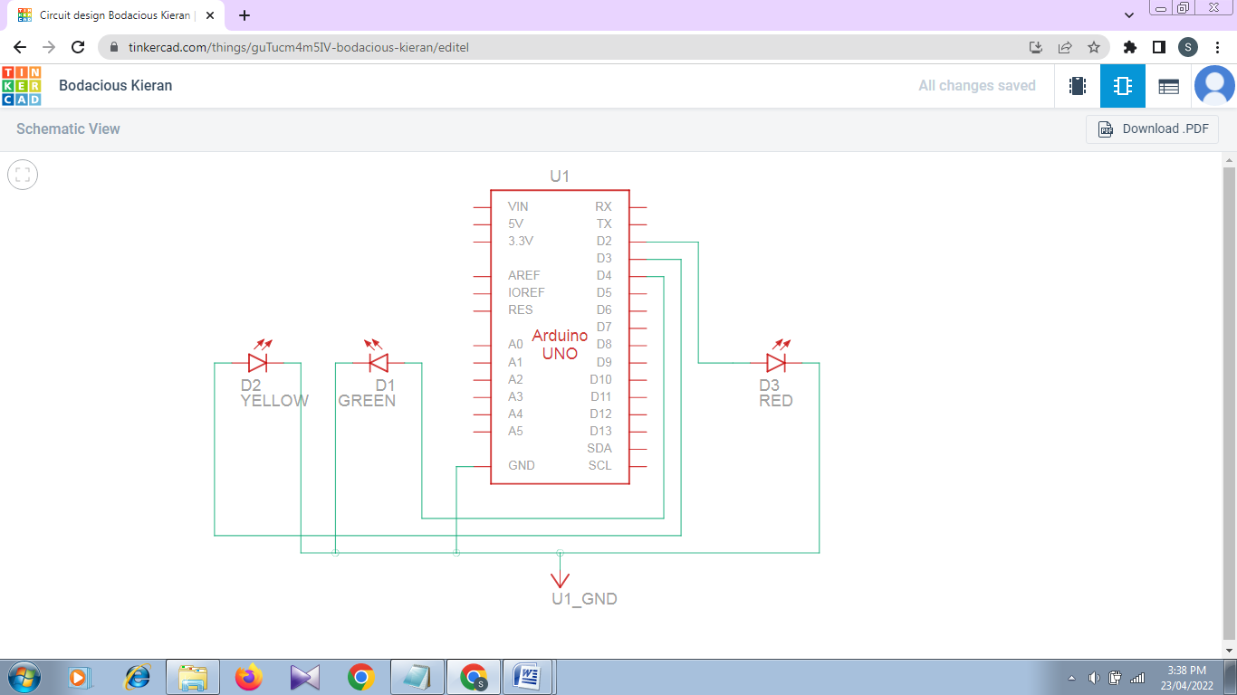

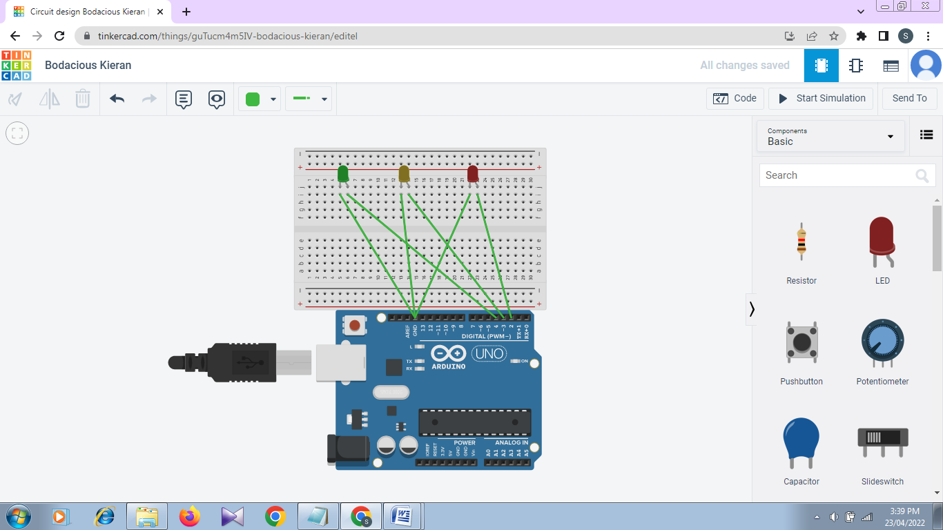**Circuit View:**

**Code:**

int green=4;

int yellow=2;

int red=3;

int i;

void setup()

{

pinMode(green, OUTPUT);

pinMode(yellow, OUTPUT);

pinMode(red, OUTPUT);

}

void loop()

{

if(i==500)

i=0;

changeLights();

i=i+1;

}

void changeLights()

{

if(i<100)

{

digitalWrite(red,LOW);

digitalWrite(yellow,LOW);

digitalWrite(green,HIGH);

delay(5);

}

else if(i>=101 && i<200)

{

digitalWrite(green,LOW);

digitalWrite(red,LOW);

digitalWrite(yellow,HIGH);

delay(5);

}

else if(i>=200 && i<300)

{

digitalWrite(yellow,LOW);

digitalWrite(green,LOW);

digitalWrite(red,HIGH);

delay(5);

}

else

digitalWrite(red,LOW);

}